BWSR Update – March 2021
Board Meeting. The next meeting is scheduled for March 24th. Board meeting information is available at: https://www.bwsr.state.mn.us/board-meeting-information

Staff Updates. All staff continue to work from home offices and expect this to continue through at least 06/31/2021. Staff that work in the field have been doing some work-related travel. Darren Mayers (Buffer Specialist) is on temporary assignment to fill Brett Arne’s Board Conservationist position while Brett is on a temporary assignment as BWSR’s PRAP Coordinator (temporary assignments filling positions that can’t be permanently filled due to hiring freeze).
Clean Water Fund Grants.
The Quarterly grants newsletter is available at: https://bwsr.state.mn.us/grantsquarterly. Successful applicants for 2021 clean water fund grants are developing work plans and preparing to sign grant agreements.

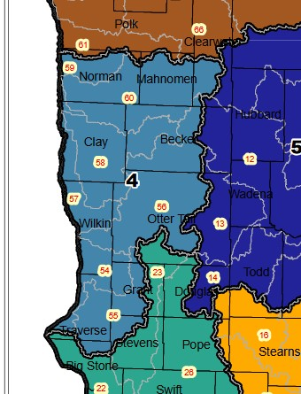
Local Government Road Wetland Replacement Program Opportunities

The Local Government Road Wetland Replacement Program (LGRWRP) was established to provide wetland mitigation for certain qualifying road reconstruction, repair and rehabilitation projects conducted by local road authorities (cities, townships, counties). BWSR provides wetland mitigation for wetland impacts incurred because of a qualifying road project. Demand has exceeded supply of wetland mitigation credits and new project sites for wetland restoration (wetland banks) are needed.
The legislature recently approved substantial funding to acquire wetland mitigation credits for this program and an RFP is expected in the next couple months. The Upper Red River watershed (BSA 4) is a high priority area for banking projects. BWSR is looking for potential project partners to link wetland restorations with ongoing or planned projects. Potential projects would need to include areas where wetland restoration potential is high – the more potential, the more yield for credit, and the higher the area ranks for selection.
If watershed districts (WDs) know of projects with partnership opportunities with BWSR to develop wetland banks, contact:
Steve Hofstad | Wetland Specialist
(o) 218-846-8423
(c) 218-770-2767
Steve.Hofstad@state.mn.us

One Watershed One Plan Program
Status of watershed planning efforts in the Red River Basin (03/08/21)

Watershed | Status
Red Lake | Plan complete. Locally adopted. Working on second implementation work plan.
Thief | Plan complete. Locally adopted. Working on first implementation work plan.
Wild Rice / Marsh | Plan complete. BWSR approved. Working on local adoption. Working on grant agreement/work plan.
Buffalo-Red | Plan complete. BWSR approved. Locally adopted. Grant agreement should be in place before the end of March.
Mustinka / Bois de Sioux | Plan complete. BWSR approved. Locally adopted. Grant agreement should be in place by mid-March.
Two Rivers Plus | Plan fully drafted. In 60-day final review period. Expected to go to BWSR Northern Committee in June.
Middle-Snake-Tamarac | Planning grant agreement in place. Steering team and policy committee beginning to work through initial planning phases
Clearwater | Planning grant agreement in place. Steering team and policy committee beginning to work through initial planning phases.
Otter Tail | Developing grant work plan, budget, and timeline. Expect MOU to be complete by end of March with grant agreement to follow soon thereafter.
Roseau & Sand Hill River | May apply for 2021 grant program.

Legislative Updates
MMB February budget forecast showed a positive turn for expected revenues. A variety of budget bills related to BWSR funding are moving forward consistent with the Governor’s recommendations. The Governor’s recommendations for clean water fund appropriations are consistent with the recommendations of the Clean Water Council including $108 million of pass through funding to BWSR for local implementation (i.e clean water fund grants). SWCD capacity funding through clean water funds was not included in the Governor’s budget. The Governor’s recommendations included a $5.5 million soil health initiative (HF936/SF1036) and a $3 million water storage program (HF932/SF1037). BWSR staff are beginning to discuss the implications of these bills and the prospective policies and programs that may need to be developed.

